Pentagonal Cupola
# Source: AI Source: Provided by: [Data Path: Persons Table -> ID Column: 1, Name_En Column: Motasem Essam] -> From: [ChatGPT] on [7/25/2026]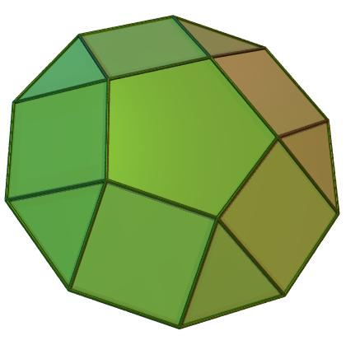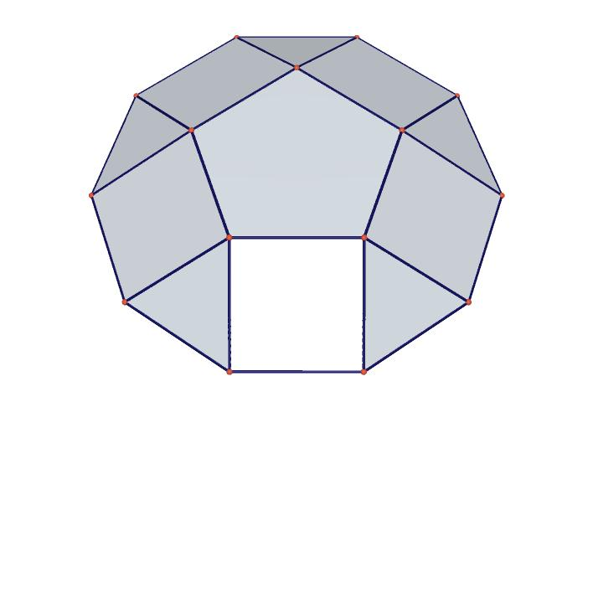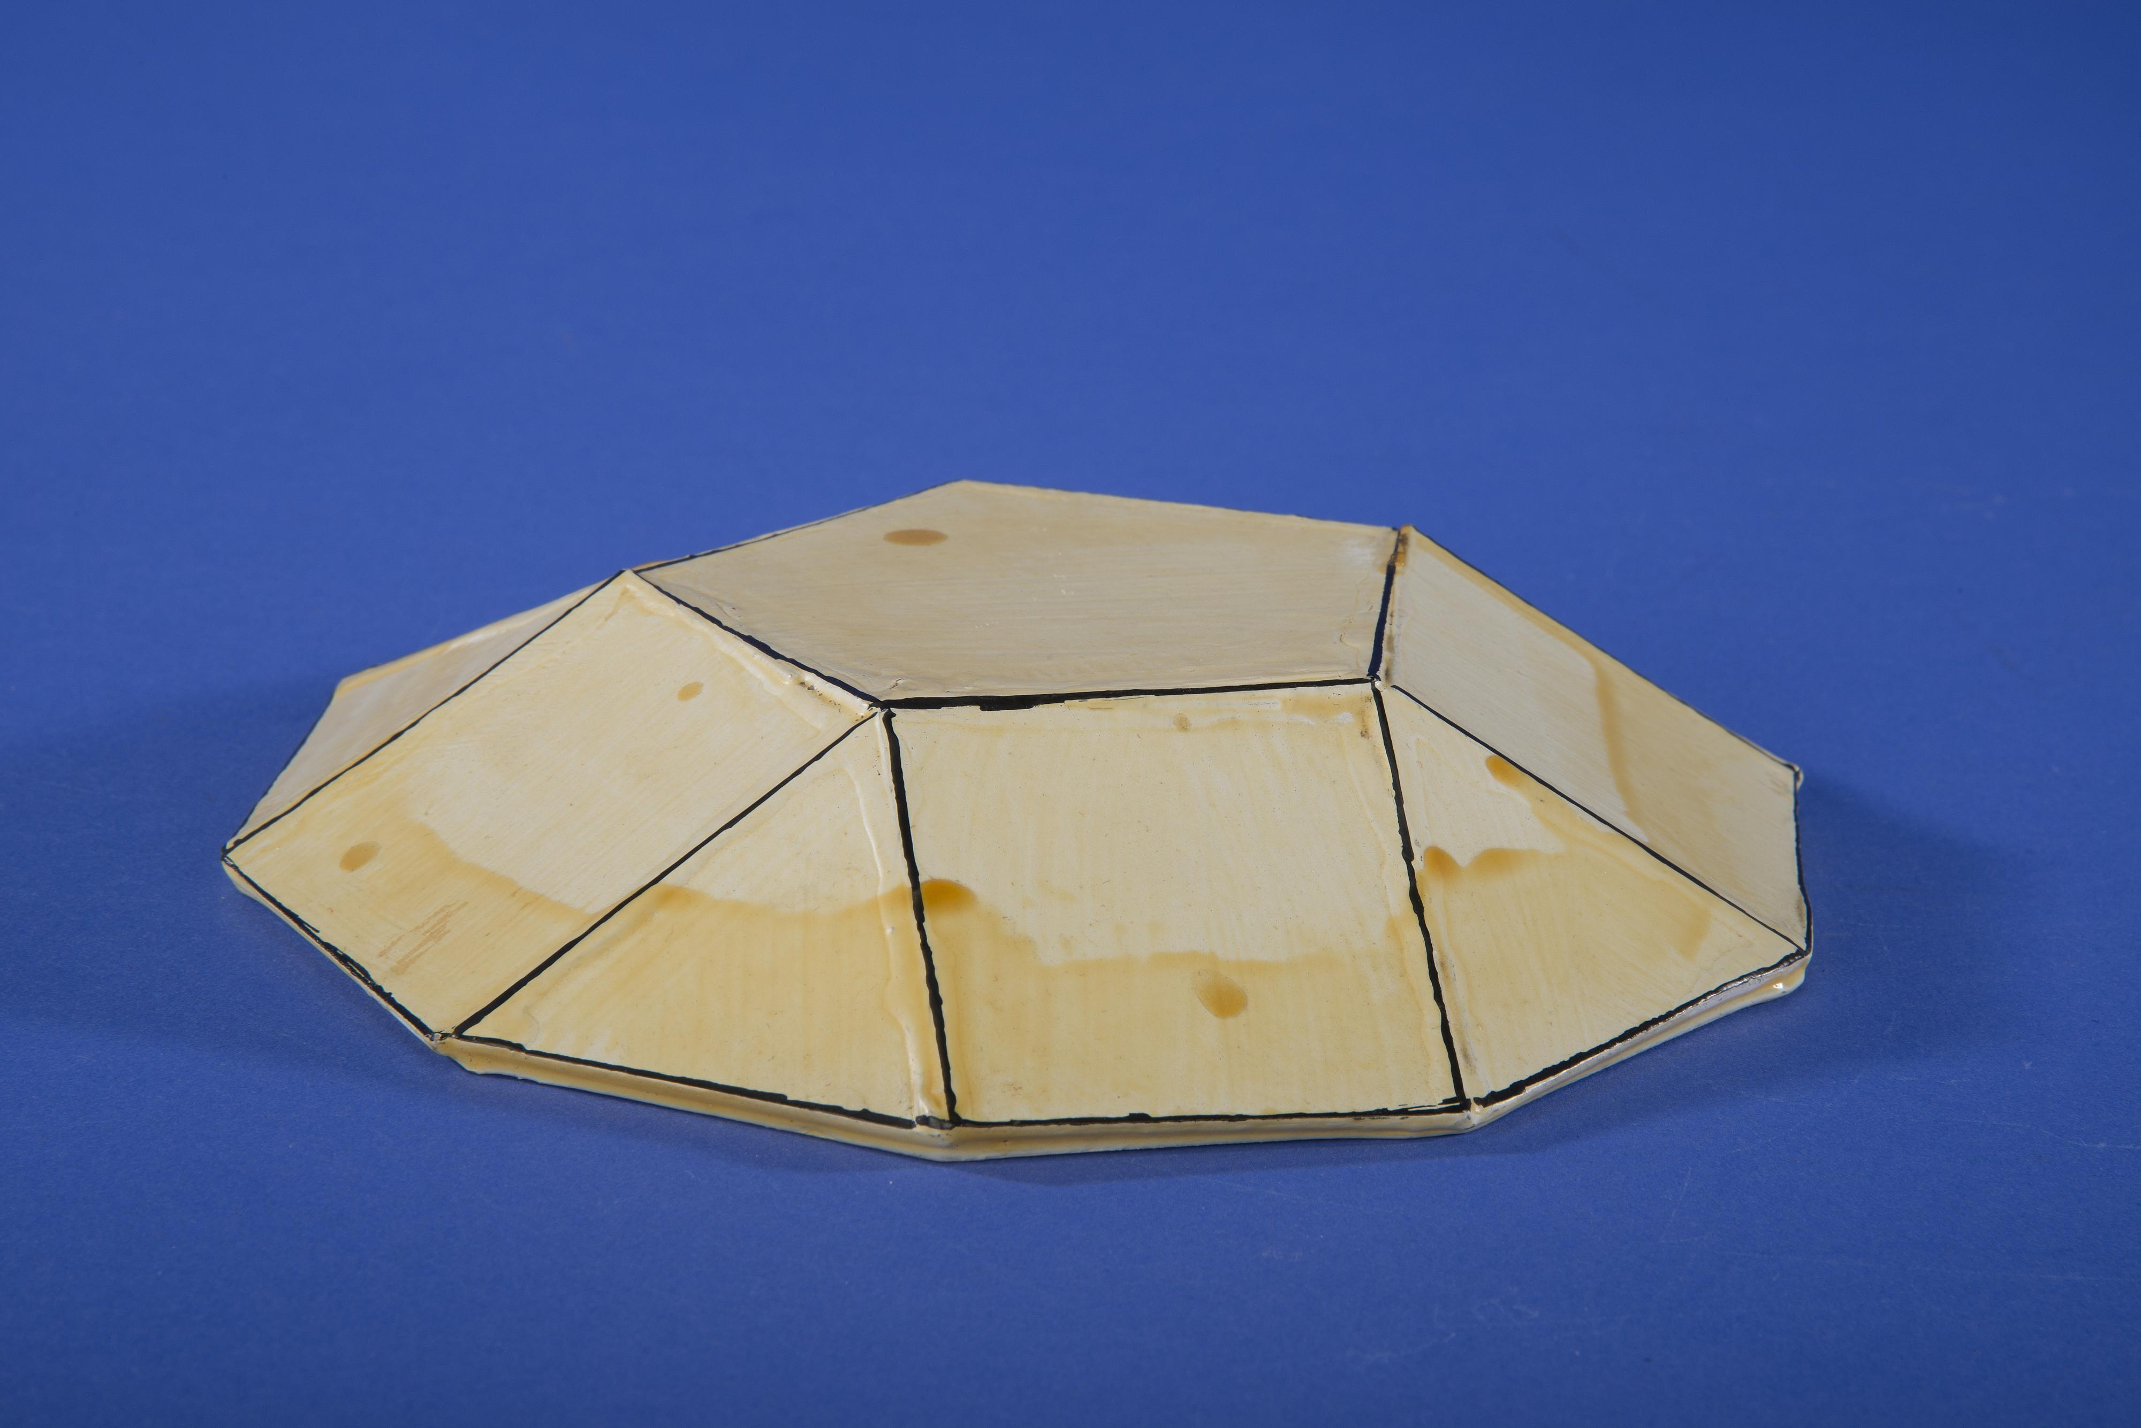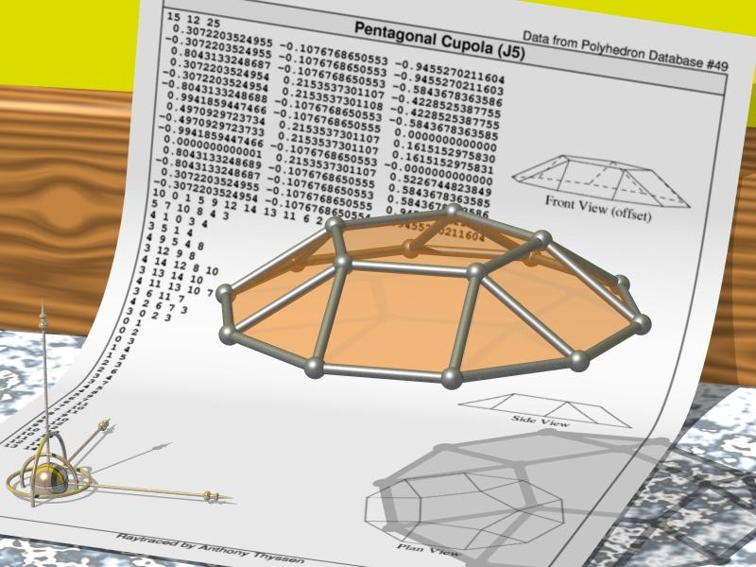

Definition
# Source: AI Source: Provided by: [Data Path: Persons Table -> ID Column: 1, Name_En Column: Motasem Essam] -> From: [ChatGPT] on [7/25/2026]
A Pentagonal Cupola is a convex polyhedron consisting of:
- One pentagonal upper base.
- One regular decagonal lower base.
- Five equilateral triangular lateral faces.
- Five square lateral faces.
The two bases are parallel, and the triangular and square lateral faces alternate around the sides of the cupola.
The pentagonal cupola is one of the Johnson solids, specifically Johnson solid J5.

Geometric Structure
# Source: AI Source: Provided by: [Data Path: Persons Table -> ID Column: 1, Name_En Column: Motasem Essam] -> From: [ChatGPT] on [7/25/2026]
- Upper Base: A regular pentagon.
- Lower Base: A regular decagon.
- Lateral Faces: Ten faces arranged alternately:
- 5 equilateral triangles.
- 5 squares.
- Arrangement: The pentagonal base is positioned above the decagonal base, with alternating triangular and square faces connecting their edges.

Face Composition
# Source: AI Source: Provided by: [Data Path: Persons Table -> ID Column: 1, Name_En Column: Motasem Essam] -> From: [ChatGPT] on [7/25/2026]
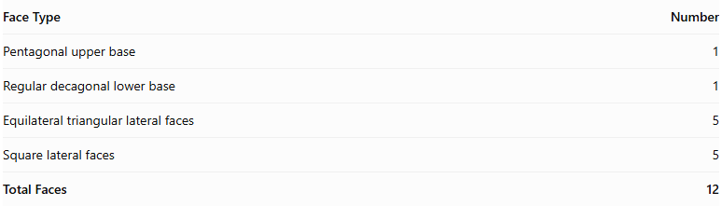
Face Type | Number
Pentagonal upper base | 1
Regular decagonal lower base | 1
Equilateral triangular lateral faces | 5
Square lateral faces | 5
Total Faces | 12

Mathematical Properties
# Source: AI Source: Provided by: [Data Path: Persons Table -> ID Column: 1, Name_En Column: Motasem Essam] -> From: [ChatGPT] on [7/25/2026]
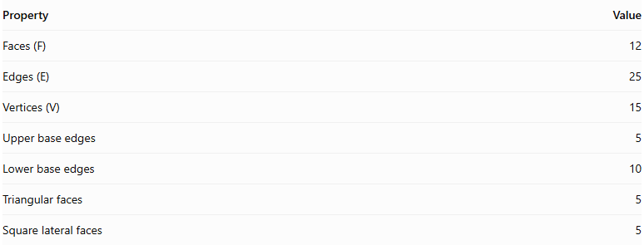
Property | Value
Faces (F) | 12
Edges (E) | 25
Vertices (V) | 15
Upper base edges | 5
Lower base edges | 10
Triangular faces | 5
Square lateral faces | 5
Euler's Formula:
$$V-E+F=2$$
$$15-25+12=2$$
<badge color="success">Euler's formula verified</badge>

Geometric Characteristics
# Source: AI Source: Provided by: [Data Path: Persons Table -> ID Column: 1, Name_En Column: Motasem Essam] -> From: [ChatGPT] on [7/25/2026]
- The pentagonal and decagonal bases are parallel.
- The upper pentagon has 5 vertices.
- The lower decagon has 10 vertices.
- The lateral faces alternate between triangles and squares.
- The solid has rotational symmetry of order 5.
- It is a convex polyhedron.

Constructing Pentagonal Cupola in Solid Geometry

Geometric Instruments Used
# Source: AI Source: Provided by: [Data Path: Persons Table -> ID Column: 1, Name_En Column: Motasem Essam] -> From: [ChatGPT] on [7/25/2026]
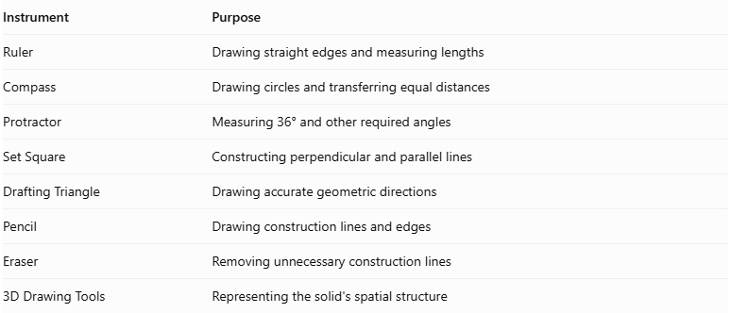
Instrument | Purpose
Ruler | Drawing straight edges and measuring lengths
Compass | Drawing circles and transferring equal distances
Protractor | Measuring 36° and other required angles
Set Square | Constructing perpendicular and parallel lines
Drafting Triangle | Drawing accurate geometric directions
Pencil | Drawing construction lines and edges
Eraser | Removing unnecessary construction lines
3D Drawing Tools | Representing the solid's spatial structure

Instrument-Based Construction Procedures
# Source: AI Source: Provided by: [Data Path: Persons Table -> ID Column: 1, Name_En Column: Motasem Essam] -> From: [ChatGPT] on [7/25/2026]
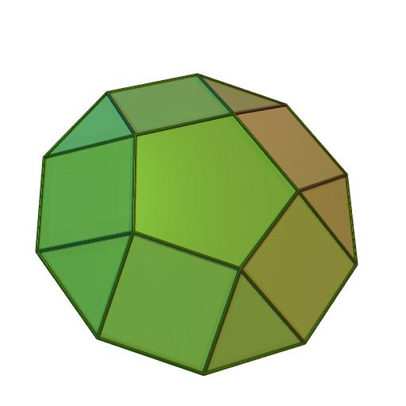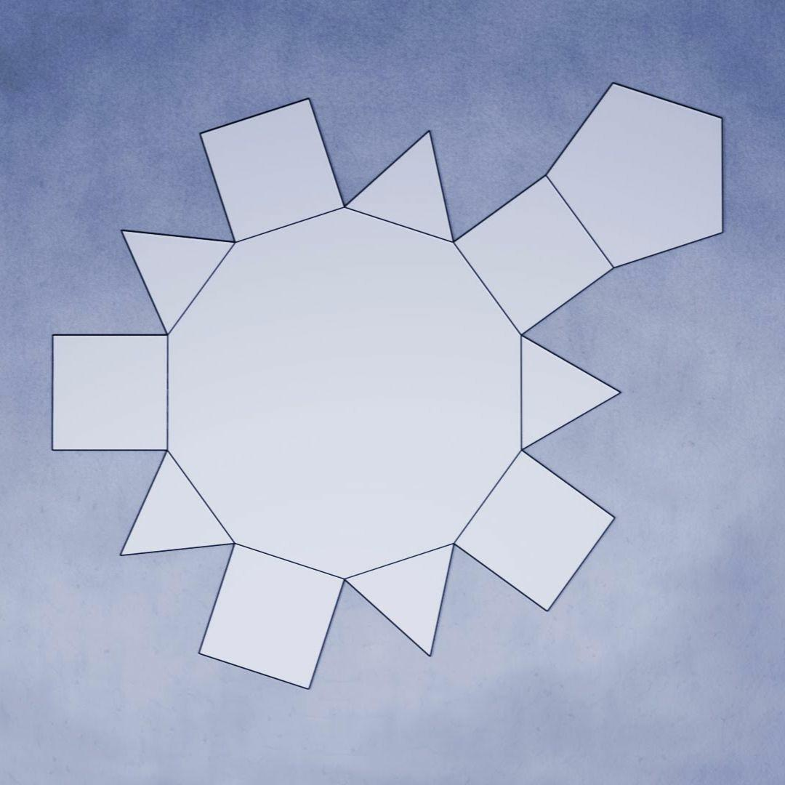

Constructing the Decagonal Base
# Source: AI Source: Provided by: [Data Path: Persons Table -> ID Column: 1, Name_En Column: Motasem Essam] -> From: [ChatGPT] on [7/25/2026]
- Draw a circle using a compass.
- Divide the circle into ten equal angular sections using a protractor, with a central angle of ${36}^{°}$.
- Mark the ten points on the circumference.
- Connect consecutive points using a ruler.
- Complete the regular decagonal base.

Constructing the Pentagonal Upper Base
# Source: AI Source: Provided by: [Data Path: Persons Table -> ID Column: 1, Name_En Column: Motasem Essam] -> From: [ChatGPT] on [7/25/2026]
- Draw a regular pentagon using a ruler, compass, and protractor as appropriate.
- Make each side equal to the required common edge length.
- Position the pentagon parallel to the decagonal base.
- Align the pentagon so that its five vertices correspond to the appropriate alternating positions around the decagonal base.
- Establish the required perpendicular separation between the two base planes.

Constructing the Lateral Faces
# Source: AI Source: Provided by: [Data Path: Persons Table -> ID Column: 1, Name_En Column: Motasem Essam] -> From: [ChatGPT] on [7/25/2026]
- Identify the five alternating groups of vertices around the decagonal base.
- Connect the appropriate decagonal vertices to the five vertices of the upper pentagon.
- Construct five square lateral faces between the corresponding base edges.
- Construct five equilateral triangular lateral faces between the square faces.
- Check that the triangular and square faces alternate around the solid.
- Ensure that all shared edges have matching lengths.

Finalizing the Solid
# Source: AI Source: Provided by: [Data Path: Persons Table -> ID Column: 1, Name_En Column: Motasem Essam] -> From: [ChatGPT] on [7/25/2026]
- Draw the visible edges using continuous lines.
- Represent hidden edges using dashed lines where necessary.
- Check the arrangement of all twelve faces.
- Verify that the pentagonal upper base and decagonal lower base are parallel.
- Erase unnecessary construction lines.
- Complete the three-dimensional representation.
Construction note: This is an instrument-based geometric construction using rulers, compasses, protractors, and geometric relationships. It is not coordinate-based construction. A protractor can be used to mark the required angular divisions for practical drawing.

Key Points
# Source: AI Source: Provided by: [Data Path: Persons Table -> ID Column: 1, Name_En Column: Motasem Essam] -> From: [ChatGPT] on [7/25/2026]
- A Pentagonal Cupola has a pentagonal upper base and a decagonal lower base.
- It contains 5 triangular and 5 square lateral faces.
- It has 12 faces, 25 edges, and 15 vertices.
- It is classified as a Johnson solid (J5).

Classification
# Source: AI Source: Provided by: [Data Path: Persons Table -> ID Column: 1, Name_En Column: Motasem Essam] -> From: [ChatGPT] on [7/25/2026]
Solid Geometry
└── Types of Solids
└── Cupola
└── Types of Cupolas
└── Pentagonal Cupola

Conclusion
# Source: AI Source: Provided by: [Data Path: Persons Table -> ID Column: 1, Name_En Column: Motasem Essam] -> From: [ChatGPT] on [7/25/2026]
The Pentagonal Cupola is a convex polyhedron formed by connecting a regular pentagon and a regular decagon with five alternating equilateral triangular faces and five square faces. It has 12 faces, 25 edges, and 15 vertices.

